Creative Brief Form
Preliminary Information
Full business name:
Abbreviated name:

Product/services offered:
Qualities & values (beyond products/services) offered:
What is different about your business:
Brief description of clients/customers:
Key message/mission statement:
3 adjectives that describe your business:

Inspiration
What are some similar businesses that are where you want to be?
Which well-known brands appeal to you?
Please attach any images or other media that you find inspirational or that represent the essence of who you are as a business.

Visual Design Options
Please choose the style you like best:

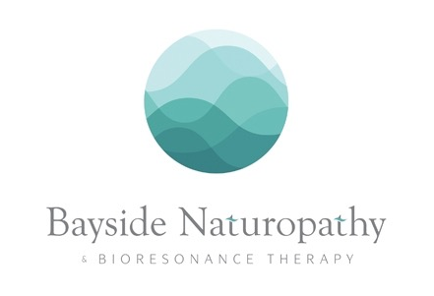
Abstract

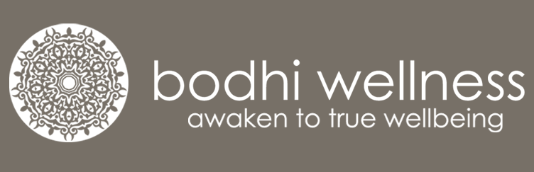

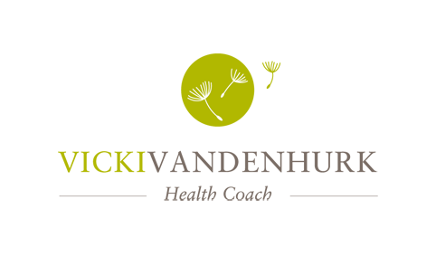
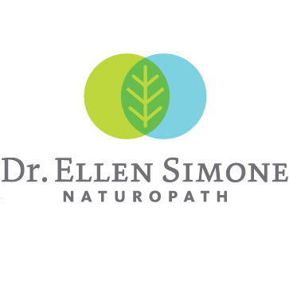
Iconographic/Plant-based

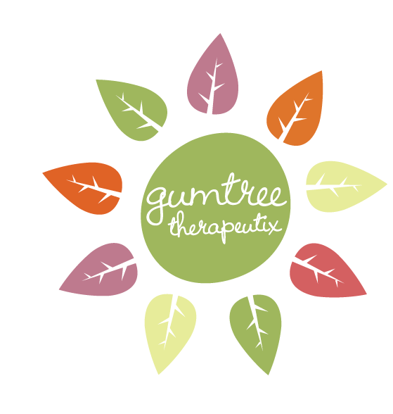
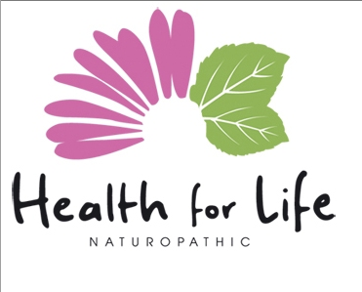
Earthy/Rustic

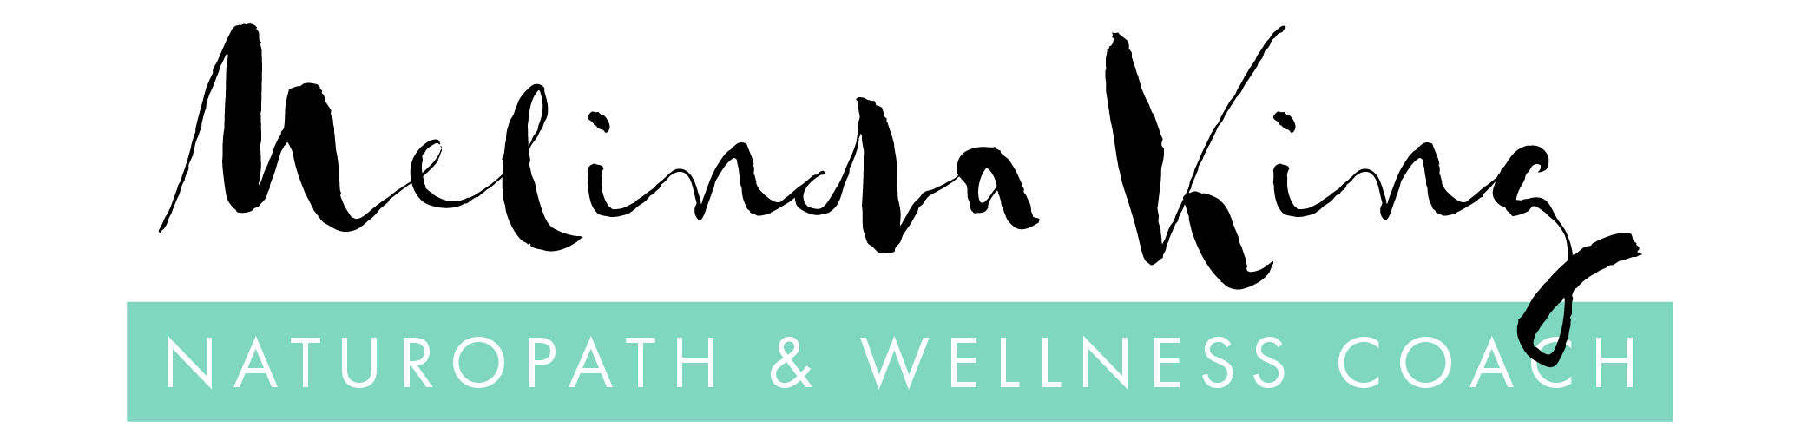

Any specific imagery requested in the logo:
Include tagline (maximum 8 words):
Include date established:
Include location:

Colour palette (please choose one)
Bright colours

Pastel colours

Muted colours

Black & white

Specific colours requested (up to 3):

Business Card Information

Contact name (if applicable):
Address:
Phone number:
Email:
Horizontal or vertical card?

Additional Notes
Please include anything that will help the designer to understand your vision.

